Chapter 18, Problem 40.

Determine the current i(t) in the circuit of Fig. 18.42(b), given the voltage source shown in Fig. 18.42(a).

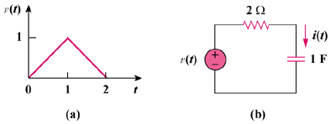

Figure 18.42
For Prob. 18.49.

